|  |  |  |
| --- | --- | --- |
|  | |  | | --- | | Lab 10:  Creating a service chatbot with Dialogflow | |

The purpose of this laboratory is to gain hands-on experience in building a chatbot that could be used as an alternative to a traditional user interface (WIMP style) for a service company. We return to your labs 4 and 5 in which you had to build a user interface for a hair salon or bike repair shop.

You will now build a simple chatbot to get the information needed to make a reservation. This information is the information you had in your traditional menus (for example, customer name, phone number, type of haircut desired, day/time of appointment, favorite professional).

The WIMP interface is now replaced by a dialogue. The client will be able to say: "I want a long haircut with Johan on Tuesday 22 July" and the chatbot will have learned to classify this sentence as an intention "GetService" and it would also have detected 3 entities (parameters) to perform the

"slot filling":

* Intention: *GetService*
* Hairstyle type: *long haircut*
* Hairdresser: *Johan*
* Date: Tuesday, *July 22*

Of course, there would be a lot to do after this stage, but we will not go any further in this lab. We will not associate our chatbot with a real action, nor will we make it very complex. This lab is an exploration of the [*Dialogflow*](https://cloud.google.com/dialogflow/docs/)[p](https://cloud.google.com/dialogflow/docs/)latform and aims to help you better understand the concepts of intentions and detection of entities.

[*Dialogflow*](https://cloud.google.com/dialogflow/docs/)[a](https://cloud.google.com/dialogflow/docs/)lso offers integration possibilities with a JavaScript-based backend, which is again compatible with the focus on JavaScript in our course. We will not do any integration into this lab, but it's a possibility for you if you want to explore conversational agents further.

In addition, Dialogflow is used by a large community, which means that there is development support with Dialogflow, as many users post information to help each other.

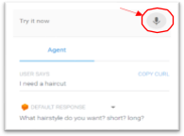And one last interesting feature is that Dialogflow contains a speech recognition module, so when you test your conversation, you can use the small microphone, as you see at the top right of this screenshot of the Dialogflow console.

Unfortunately, a small downside is that even if we can use

Dialogflow for free during a trial period, as it is software on the Google Cloud platform, you are asked for information to register, including a credit card number. We reassure you that nothing will be charged, but... If you are not comfortable with that, write an email to your TA.



SUBMISSION DEADLINE

● Sunday, March 31st, 2024, 11:59 p.m.



SUBMISSION METHOD

* In Brightspace, the lab 10 module contains a link to your submission.
* Submit a link to a video showing a small demo of your chatbot. Be concise, don't go beyond 10 minutes!
* Also, in Dialogflow, if you click the setting icon next to your agent's name, you'll have access to a menu in which there's a Share option (see image below). Please invite the TA as a reviewer. Make sure you make SAVE so that this request is backed up.

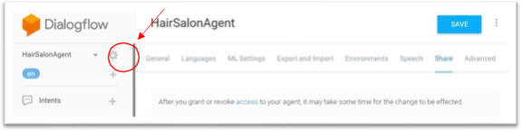

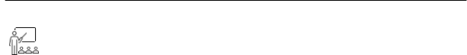

INSTRUCTIONS / TUTORIALS TO FOLLOW

Dialogflow is part of Google Cloud AI and Machine Learning products, if you follow this link: 

<https://cloud.google.com/dialogflow/docs/> you'll see the screen below.

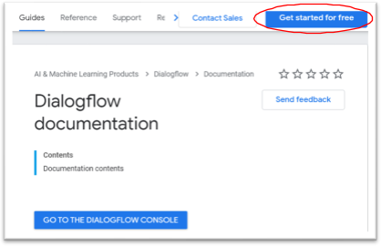

Step 1 - Access Dialogflow

First of all, you need to connect to DialogFlow. You see the "Get started for free." **Unfortunately, you cannot use your University of Ottawa account because there will be problems registering your agents.** So I suggest you use your personal Gmail account. But if you don't want to use your usual account, you can create a new Gmail account with which you can test this software.

Step 2 - Learn the chatbot model underlying Dialogflow

If you scroll through the page, you will see a link to [the](https://cloud.google.com/dialogflow/docs/video) [introductory](https://cloud.google.com/dialogflow/docs/video) [videos.](https://cloud.google.com/dialogflow/docs/video) [I](https://cloud.google.com/dialogflow/docs/video) recommend the first two episodes of the Basics **of Dialogflow** series. The first (3 min) talks about detection of intent, and the second (5 min) speaks of entity identification. You will need both for this lab. The third video is also interesting, but we will not use non-linear dialogues in this laboratory. You can watch the beginning until the discussion of "mandatory slots to fill."

Step 3 - Learn how to build an agent.

Now if you go to the [QuickStart](https://cloud.google.com/dialogflow/docs/quick) [s](https://cloud.google.com/dialogflow/docs/quick)ection, you'll see a tutorial on **build** an **agent.** It's what you’ll have to do for this lab.

The first step tells you to go to the Dialogflow console. Then, in the console, on the left, there is a list of agents (if you have already created one) and the ability to build a new agent.

When you create your agent, give it the name you want ***BUT, make sure you include your name in your agent's name*** (e.g. AgentBikeRepairShop-YourName) because you will eventually have to give your agent access to the teaching assistant, and he must be able to find yours all the other agents.

Once your agent is created, you will be able to see (and create) intentions that your agent can recognize during a dialogue.

For any new agent, Dialogflow puts 2 intentions by default: Welcome and Fallback. You will need to customize these intentions for your service. The Welcome intention is to recognize when the user says "hi" or "hello," and Fallback’s intention is when a user says something the agent doesn't understand.

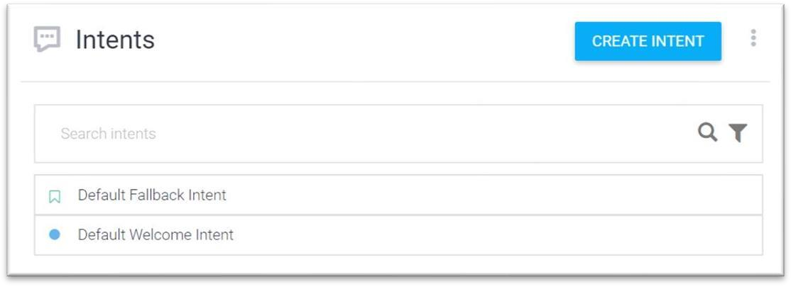

The tutorial then talks about creating new intentions, and this is where the chatbot will become even more specific to your business (hair salon/bike repair).

The tutorial will then talk about settings and entities. It will even talk about pre-defined system entities and those you can define yourself. You need all this information for your lab. Keep exploring. Everything you need to make this lab is provided in this section on **Build an Agent.**



design

In general, when we build a chatbot, a lot of time is devoted to what we call conversation design which means how we want the conversation to evolve or flow (hence the word flow in name of the platform).

But in this lab 10, we will not go very far in this design. I will provide a set of requirements in the Programming section. We keep our dialogue linear and want to plan questions to get important informationfor making an appointment (but not validate it).

Like this:

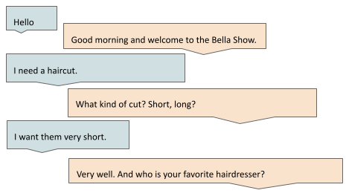

And so on... See how the welcome message (Hello and welcome to The Bella Salon) is personalized for the hair salon. In addition, you will want different ways to say Welcome, so that the agent shows a little more "human". This welcome message is the textual response to the welcome intention, which is detected first. And how was this detected? By the fact that you would provide training *sentences* that will be various paraphrases that correspond to this intention.

Thus, each intention is accompanied by training phrases and an optional text response. Often, an intention, such as *GetService* for example, can be detected from the phrase "I need a haircut", but then, this intention requires mandatory parameters (for example, haircut style, hairdresser's name, etc.) that we define in Dialogflow and for which we provide an invite (a *prompt,* for example, what type of haircut?).

The haircut style would be an entity, defined by a list of possible values (such as Enums). To prevent the user from saying anything, it's wise to include items from the list in the prompt (as you see above, the prompt is "what type of cut?" Short, long?).



STARTING POINT

I don't provide a starting code for this lab. Dialogflow has default intentions, such as welcome and fallback intentions, as they would occur in almost every dialogue. So you don't have to start over. You will see that there are already many training phrases like paraphrases of “hello."

Also, you can explore the "Prebuilt agents" shown in Dialogflow. They are agents designed for all kinds of situations. But it's easy to get lost in all these examples...

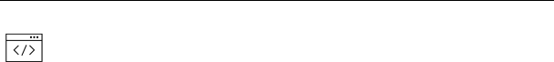

programming:

There is no programming per se in this lab, but rather the "programming" of your conversational agent regarding:

* intentions to recognize and for which you provide workout phrases (paraphrases containing various subsets of required entities)
* required entities, associated with intentions and for which you provide prompts.
* intentions to which you must respond and for which you will give some possible answers.

Here are the requirements:

* A personalized welcome intention. This means that you have modified the text responses to have 3 ways to say hello/welcome to your business.
* A custom Fallback intention. This means that you change the text responses to tell the user another phrase other than "Sorry, I don't understand". Give more productive examples of user phrases that the agent understands.
* A thank you intention, for which you can define 5 training phrases and 3 possible textual responses. This intention corresponds to the user who would say "thank you."
* A NeedService intention, for which you set certain parameters (haircut style/bike repair type, professional (favorite hairdresser/mechanic), date, time, customer name, customer phone number) as mandatory. Plan at least 15 sentences for this purpose. Each sentence will include a subset of the required entities.
* Set the settings used with the NeedService intent. Some will be predefined types in Dialogflow (e.g. @sys.date-time, @sys.phone-number) but others you will need to define as entities.
* For any predefined entity, you can assume that Dialogflow already has examples of training. But, for the entities you set, you have to provide training phrases.
* Set at least 3 prompts for each required setting.

There will be no validation of correct/incorrect dates/hours given the chosen professional. No action will also be taken after the linear dialogue. So, we're just gathering information.

The number of training phrases and textual responses given above is a minimum number required for your lab. But we are using "machine learning" behind the scenes... and so the more examples of training you give to Dialogflow for each of your intentions, the better the chatbot will be able to properly classify the user's intentions and extract the required parameters.



EVALUATION

* Lab 10 is worth 3%
* The TA will watch your short video (max 10 minutes) in which:
  1. First, simulate a small conversation for making an appointment. Your conversation should include:
     + Exchange for Hello/Welcome
     + Something the user says the chatbot does not understand to show the answer to the *Fallback intention*.
     + A request for an appointment with partial info (NeedService intention)
     + Requests for information by the chatbot
     + A thank you from the user to whom the chatbot responds to show the answer to the *thank you intention*.
  2. Then show the list of intentions in Dialogflow and show a set of training phrases for each intention.
  3. Show your settings and their types (the features you had to set or the predefined types), as well as the prompts used to get their values).

● You will also share your agent with the TA, and they'll be able to see what you've done.

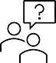

Questions

• You can also send your questions directly to TAs